Filed by Tempus AI, Inc.
Pursuant to Rule 425 under the Securities Act of 1933,
as amended, and deemed filed pursuant to 14a-12
under the Securities Exchange Act of 1934, as amended
Subject Company: Personalis, Inc.
Commission File No.: 001-38943
On July 20, 2026, Tempus AI, Inc. (“Tempus”) displayed the following presentation materials during a meeting with Tempus investors in connection with its announcement of an agreement to acquire Personalis, Inc.
Tempus – Investor Deck

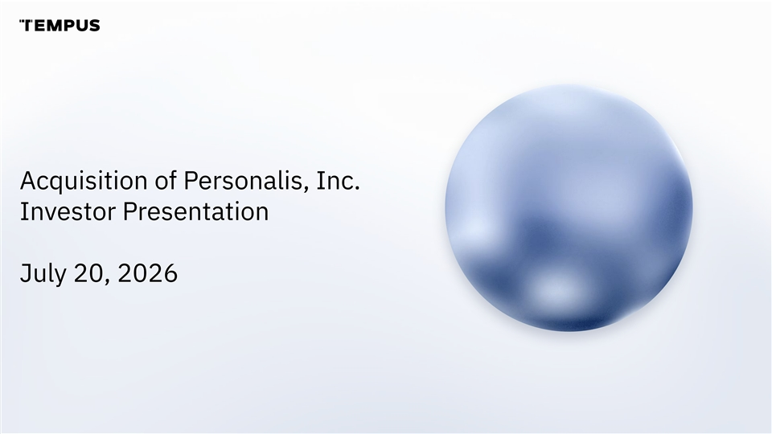
Acquisition of Personalis, Inc. Investor Presentation July 20, 2026

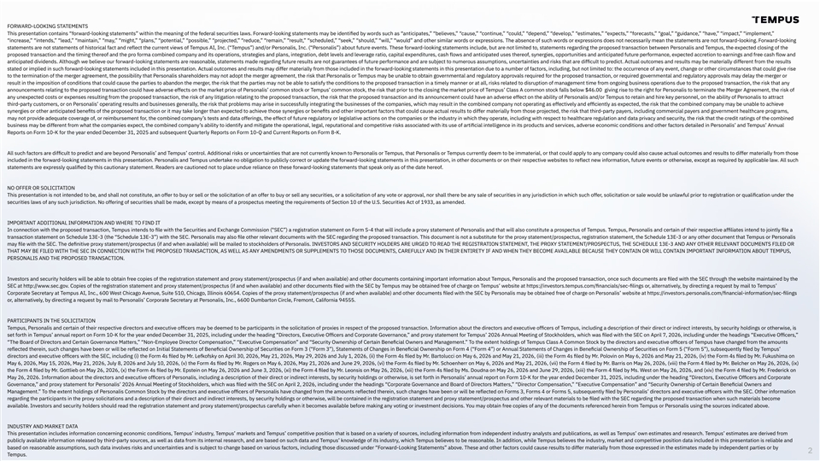
FORWARD-LOOKING STATEMENTS This presentation contains “forward-looking statements” within the meaning of the federal securities laws. Forward-looking statements may be identiﬁed by words such as “anticipates,” “believes,” “cause,” “continue,” “could,” “depend,” “develop,” “estimates,” “expects,” “forecasts,” “goal,” “guidance,” “have,” “impact,” “implement,” “increase,” “intends,” “lead,” “maintain,” “may,” “might,” “plans,” “potential,” “possible,” “projected,” “reduce,” “remain,” “result,” “scheduled,” “seek,” “should,” “will,” “would” and other similar words or expressions. The absence of such words or expressions does not necessarily mean the statements are not forward-looking. Forward-looking statements are not statements of historical fact and reflect the current views of Tempus AI, Inc. (“Tempus”) and/or Personalis, Inc. (“Personalis”) about future events. These forward-looking statements include, but are not limited to, statements regarding the proposed transaction between Personalis and Tempus, the expected closing of the proposed transaction and the timing thereof and the pro forma combined company and its operations, strategies and plans, integration, debt levels and leverage ratio, capital expenditures, cash flows and anticipated uses thereof, synergies, opportunities and anticipated future performance, expected accretion to earnings and free cash flow and anticipated dividends. Although we believe our forward-looking statements are reasonable, statements made regarding future results are not guarantees of future performance and are subject to numerous assumptions, uncertainties and risks that are difﬁcult to predict. Actual outcomes and results may be materially different from the results stated or implied in such forward-looking statements included in this presentation. Actual outcomes and results may differ materially from those included in the forward-looking statements in this presentation due to a number of factors, including, but not limited to: the occurrence of any event, change or other circumstances that could give rise to the termination of the merger agreement, the possibility that Personalis shareholders may not adopt the merger agreement, the risk that Personalis or Tempus may be unable to obtain governmental and regulatory approvals required for the proposed transaction, or required governmental and regulatory approvals may delay the merger or result in the imposition of conditions that could cause the parties to abandon the merger, the risk that the parties may not be able to satisfy the conditions to the proposed transaction in a timely manner or at all, risks related to disruption of management time from ongoing business operations due to the proposed transaction, the risk that any announcements relating to the proposed transaction could have adverse effects on the market price of Personalis’ common stock or Tempus’ common stock, the risk that prior to the closing the market price of Tempus’ Class A common stock falls below $46.00 giving rise to the right for Personalis to terminate the Merger Agreement, the risk of any unexpected costs or expenses resulting from the proposed transaction, the risk of any litigation relating to the proposed transaction, the risk that the proposed transaction and its announcement could have an adverse effect on the ability of Personalis and/or Tempus to retain and hire key personnel, on the ability of Personalis to attract third-party customers, or on Personalis’ operating results and businesses generally, the risk that problems may arise in successfully integrating the businesses of the companies, which may result in the combined company not operating as effectively and efﬁciently as expected, the risk that the combined company may be unable to achieve synergies or other anticipated beneﬁts of the proposed transaction or it may take longer than expected to achieve those synergies or beneﬁts and other important factors that could cause actual results to differ materially from those projected, the risk that third-party payers, including commercial payers and government healthcare programs, may not provide adequate coverage of, or reimbursement for, the combined company’s tests and data offerings, the effect of future regulatory or legislative actions on the companies or the industry in which they operate, including with respect to healthcare regulation and data privacy and security, the risk that the credit ratings of the combined business may be different from what the companies expect, the combined company’s ability to identify and mitigate the operational, legal, reputational and competitive risks associated with its use of artiﬁcial intelligence in its products and services, adverse economic conditions and other factors detailed in Personalis’ and Tempus’ Annual Reports on Form 10-K for the year ended December 31, 2025 and subsequent Quarterly Reports on Form 10-Q and Current Reports on Form 8-K. All such factors are difﬁcult to predict and are beyond Personalis’ and Tempus’ control. Additional risks or uncertainties that are not currently known to Personalis or Tempus, that Personalis or Tempus currently deem to be immaterial, or that could apply to any company could also cause actual outcomes and results to differ materially from those included in the forward-looking statements in this presentation. Personalis and Tempus undertake no obligation to publicly correct or update the forward-looking statements in this presentation, in other documents or on their respective websites to reflect new information, future events or otherwise, except as required by applicable law. All such statements are expressly qualiﬁed by this cautionary statement. Readers are cautioned not to place undue reliance on these forward-looking statements that speak only as of the date hereof. NO OFFER OR SOLICITATION This presentation is not intended to be, and shall not constitute, an offer to buy or sell or the solicitation of an offer to buy or sell any securities, or a solicitation of any vote or approval, nor shall there be any sale of securities in any jurisdiction in which such offer, solicitation or sale would be unlawful prior to registration or qualiﬁcation under the securities laws of any such jurisdiction. No offering of securities shall be made, except by means of a prospectus meeting the requirements of Section 10 of the U.S. Securities Act of 1933, as amended. IMPORTANT ADDITIONAL INFORMATION AND WHERE TO FIND IT In connection with the proposed transaction, Tempus intends to ﬁle with the Securities and Exchange Commission ( SEC”) a registration statement on Form S-4 that will include a proxy statement of Personalis and that will also constitute a prospectus of Tempus. Tempus, Personalis and certain of their respective afﬁliates intend to jointly ﬁle a transaction statement on Schedule 13E-3 (the “Schedule 13E-3”) with the SEC. Personalis may also ﬁle other relevant documents with the SEC regarding the proposed transaction. This document is not a substitute for the proxy statement/prospectus, registration statement, the Schedule 13E-3 or any other document that Tempus or Personalis may ﬁle with the SEC. The deﬁnitive proxy statement/prospectus (if and when available) will be mailed to stockholders of Personalis. INVESTORS AND SECURITY HOLDERS ARE URGED TO READ THE REGISTRATION STATEMENT, THE PROXY STATEMENT/PROSPECTUS, THE SCHEDULE 13E-3 AND ANY OTHER RELEVANT DOCUMENTS FILED OR THAT MAY BE FILED WITH THE SEC IN CONNECTION WITH THE PROPOSED TRANSACTION, AS WELL AS ANY AMENDMENTS OR SUPPLEMENTS TO THOSE DOCUMENTS, CAREFULLY AND IN THEIR ENTIRETY IF AND WHEN THEY BECOME AVAILABLE BECAUSE THEY CONTAIN OR WILL CONTAIN IMPORTANT INFORMATION ABOUT TEMPUS, PERSONALIS AND THE PROPOSED TRANSACTION. Investors and security holders will be able to obtain free copies of the registration statement and proxy statement/prospectus (if and when available) and other documents containing important information about Tempus, Personalis and the proposed transaction, once such documents are ﬁled with the SEC through the website maintained by the SEC at http://www.sec.gov. Copies of the registration statement and proxy statement/prospectus (if and when available) and other documents ﬁled with the SEC by Tempus may be obtained free of charge on Tempus’ website at https://investors.tempus.com/ﬁnancials/sec-ﬁlings or, alternatively, by directing a request by mail to Tempus’ Corporate Secretary at Tempus AI, Inc., 600 West Chicago Avenue, Suite 510, Chicago, Illinois 60654. Copies of the proxy statement/prospectus (if and when available) and other documents ﬁled with the SEC by Personalis may be obtained free of charge on Personalis’ website at https://investors.personalis.com/ﬁnancial-information/sec-ﬁlings or, alternatively, by directing a request by mail to Personalis’ Corporate Secretary at Personalis, Inc., 6600 Dumbarton Circle, Fremont, California 94555. PARTICIPANTS IN THE SOLICITATION Tempus, Personalis and certain of their respective directors and executive ofﬁcers may be deemed to be participants in the solicitation of proxies in respect of the proposed transaction. Information about the directors and executive ofﬁcers of Tempus, including a description of their direct or indirect interests, by security holdings or otherwise, is set forth in Tempus’ annual report on Form 10-K for the year ended December 31, 2025, including under the heading “Directors, Executive Ofﬁcers and Corporate Governance,” and proxy statement for Tempus’ 2026 Annual Meeting of Stockholders, which was ﬁled with the SEC on April 7, 2026, including under the headings “Executive Ofﬁcers,” “The Board of Directors and Certain Governance Matters,” “Non-Employee Director Compensation,” “Executive Compensation” and “Security Ownership of Certain Beneﬁcial Owners and Management.” To the extent holdings of Tempus Class A Common Stock by the directors and executive ofﬁcers of Tempus have changed from the amounts reflected therein, such changes have been or will be reflected on Initial Statements of Beneﬁcial Ownership of Securities on Form 3 (“Form 3”), Statements of Changes in Beneﬁcial Ownership on Form 4 (“Form 4”) or Annual Statements of Changes in Beneﬁcial Ownership of Securities on Form 5 (“Form 5”), subsequently ﬁled by Tempus’ directors and executive ofﬁcers with the SEC, including (i) the Form 4s ﬁled by Mr. Lefkofsky on April 30, 2026, May 21, 2026, May 29, 2026 and July 1, 2026, (ii) the Form 4s ﬁled by Mr. Bartolucci on May 6, 2026 and May 21, 2026, (iii) the Form 4s ﬁled by Mr. Polovin on May 6, 2026 and May 21, 2026, (iv) the Form 4s ﬁled by Mr. Fukushima on May 6, 2026, May 15, 2026, May 21, 2026, July 8, 2026 and July 10, 2026, (v) the Form 4s ﬁled by Mr. Rogers on May 6, 2026, May 21, 2026 and June 29, 2026, (vi) the Form 4s ﬁled by Mr. Schoenherr on May 6, 2026 and May 21, 2026, (vii) the Form 4 ﬁled by Mr. Barris on May 26, 2026, (viii) the Form 4 ﬁled by Mr. Belcher on May 26, 2026, (ix) the Form 4 ﬁled by Mr. Gottlieb on May 26, 2026, (x) the Form 4s ﬁled by Mr. Epstein on May 26, 2026 and June 3, 2026, (xi) the Form 4 ﬁled by Mr. Leonsis on May 26, 2026, (xii) the Form 4s ﬁled by Ms. Doudna on May 26, 2026 and June 29, 2026, (xiii) the Form 4 ﬁled by Ms. West on May 26, 2026, and (xiv) the Form 4 ﬁled by Mr. Frederick on May 26, 2026. Information about the directors and executive ofﬁcers of Personalis, including a description of their direct or indirect interests, by security holdings or otherwise, is set forth in Personalis’ annual report on Form 10-K for the year ended December 31, 2025, including under the heading “Directors, Executive Ofﬁcers and Corporate Governance,” and proxy statement for Personalis’ 2026 Annual Meeting of Stockholders, which was ﬁled with the SEC on April 2, 2026, including under the headings “Corporate Governance and Board of Directors Matters,” “Director Compensation,” “Executive Compensation” and “Security Ownership of Certain Beneﬁcial Owners and Management.” To the extent holdings of Personalis Common Stock by the directors and executive ofﬁcers of Personalis have changed from the amounts reflected therein, such changes have been or will be reflected on Forms 3, Forms 4 or Forms 5, subsequently ﬁled by Personalis’ directors and executive ofﬁcers with the SEC. Other information regarding the participants in the proxy solicitations and a description of their direct and indirect interests, by security holdings or otherwise, will be contained in the registration statement and proxy statement/prospectus and other relevant materials to be ﬁled with the SEC regarding the proposed transaction when such materials become available. Investors and security holders should read the registration statement and proxy statement/prospectus carefully when it becomes available before making any voting or investment decisions. You may obtain free copies of any of the documents referenced herein from Tempus or Personalis using the sources indicated above. INDUSTRY AND MARKET DATA This presentation includes information concerning economic conditions, Tempus’ industry, Tempus’ markets and Tempus’ competitive position that is based on a variety of sources, including information from independent industry analysts and publications, as well as Tempus’ own estimates and research. Tempus’ estimates are derived from publicly available information released by third-party sources, as well as data from its internal research, and are based on such data and Tempus’ knowledge of its industry, which Tempus believes to be reasonable. In addition, while Tempus believes the industry, market and competitive position data included in this presentation is reliable and based on reasonable assumptions, such data involves risks and uncertainties and is subject to change based on various factors, including those discussed under “Forward-Looking Statements” above. These and other factors could cause results to differ materially from those expressed in the estimates made by independent parties or by 2 Tempus.

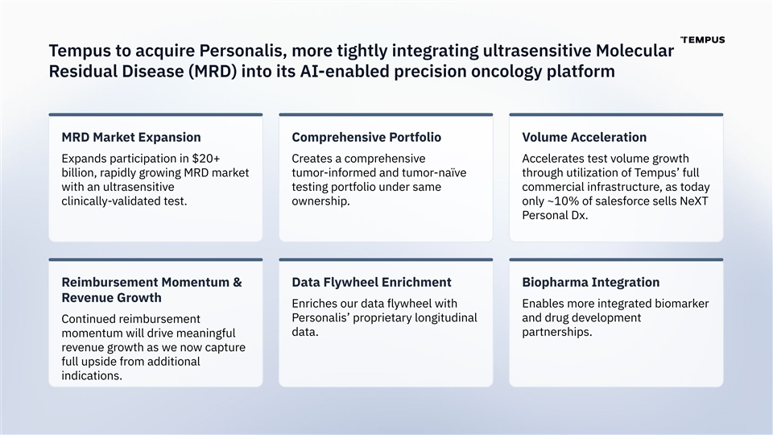
Tempus to acquire Personalis, more tightly integrating ultrasensitive Molecular Residual Disease (MRD) into its AI-enabled precision oncology platform MRD Market Expansion Comprehensive Portfolio Volume Acceleration Expands participation in $20+ Creates a comprehensive Accelerates test volume growth billion, rapidly growing MRD market tumor-informed and tumor-naïve through utilization of Tempus’ full with an ultrasensitive testing portfolio under same commercial infrastructure, as today clinically-validated test. ownership. only ~10% of salesforce sells NeXT Personal Dx. Reimbursement Momentum & Data Flywheel Enrichment Biopharma Integration Revenue Growth Enriches our data flywheel with Enables more integrated biomarker Personalis’ proprietary longitudinal and drug development Continued reimbursement data. partnerships. momentum will drive meaningful revenue growth as we now capture full upside from additional indications.

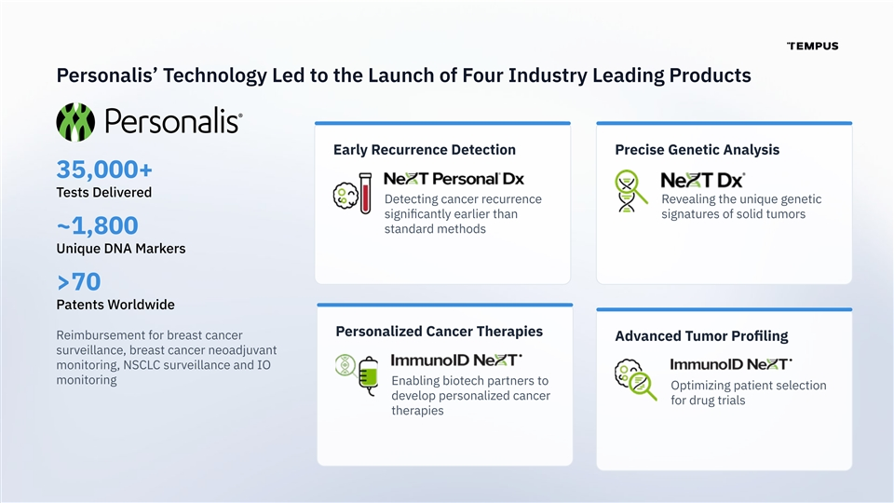
Personalis’ Technology Led to the Launch of Four Industry Leading Products Early Recurrence Detection Precise Genetic Analysis 35,000+ Tests Delivered Detecting cancer recurrence Revealing the unique genetic signiﬁcantly earlier than signatures of solid tumors standard methods ~1,800 Unique DNA Markers >70 Patents Worldwide Personalized Cancer Therapies Reimbursement for breast cancer Advanced Tumor Proﬁling surveillance, breast cancer neoadjuvant monitoring, NSCLC surveillance and IO monitoring Enabling biotech partners to Optimizing patient selection develop personalized cancer for drug trials therapies

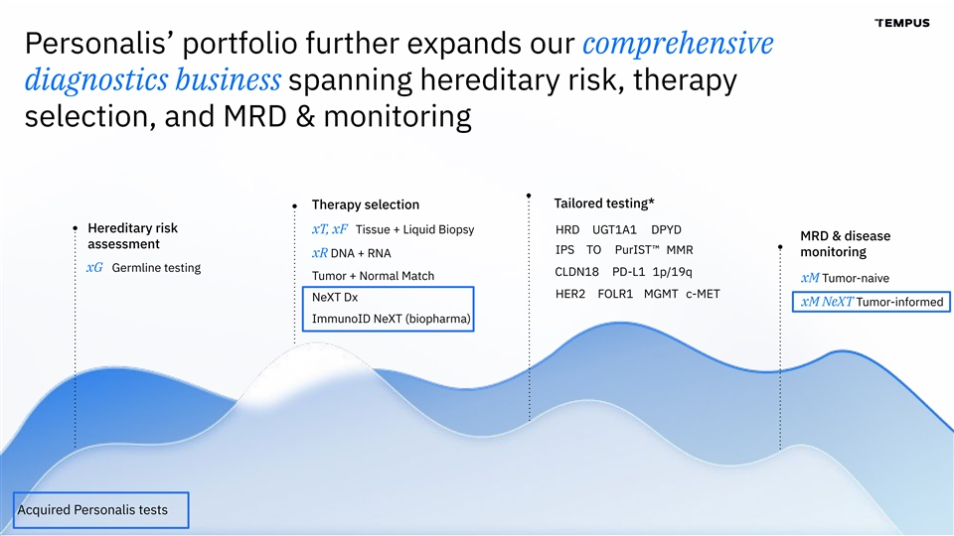
Personalis’ portfolio further expands our comprehensive diagnostics business spanning hereditary risk, therapy selection, and MRD & monitoring Tailored testing* Therapy selection Hereditary risk xT, xF Tissue + Liquid Biopsy HRD UGT1A1 DPYD MRD & disease assessment IPS TO PurIST™ MMR monitoring xR DNA + RNA xG Germline testing CLDN18 PD-L1 1p/19q Tumor + Normal Match xM Tumor-naive HER2 FOLR1 MGMT c-MET NeXT Dx xM NeXT Tumor-informed ImmunoID NeXT (biopharma) Acquired Personalis tests

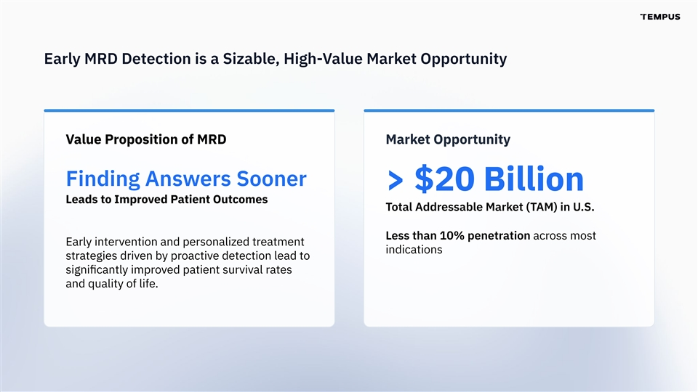
Early MRD Detection is a Sizable, High-Value Market Opportunity Value Proposition of MRD Market Opportunity Finding Answers Sooner > $20 Billion Leads to Improved Patient Outcomes Total Addressable Market (TAM) in U.S. Less than 10% penetration across most Early intervention and personalized treatment indications strategies driven by proactive detection lead to signiﬁcantly improved patient survival rates and quality of life.

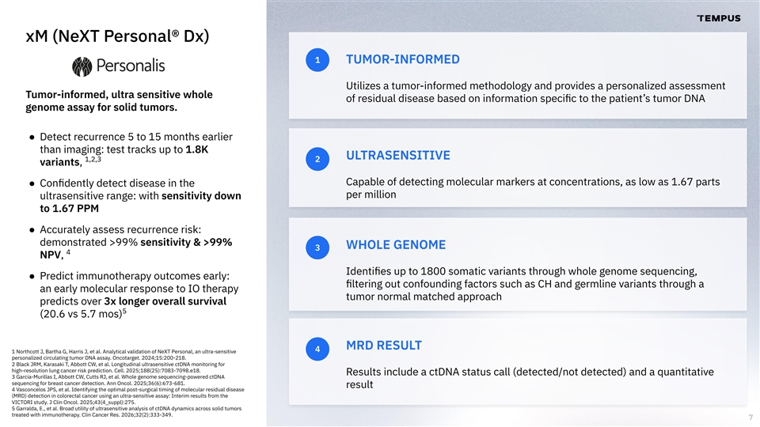
xM (NeXT Personal® Dx) 1 TUMOR-INFORMED Utilizes a tumor-informed methodology and provides a personalized assessment Tumor-informed, ultra sensitive whole of residual disease based on information speciﬁc to the patient’s tumor DNA genome assay for solid tumors. ● Detect recurrence 5 to 15 months earlier than imaging: test tracks up to 1.8K ULTRASENSITIVE 1,2,3 2 variants, Capable of detecting molecular markers at concentrations, as low as 1.67 parts ● Conﬁdently detect disease in the per million ultrasensitive range: with sensitivity down to 1.67 PPM ● Accurately assess recurrence risk: demonstrated >99% sensitivity & >99% WHOLE GENOME 3 4 NPV, Identiﬁes up to 1800 somatic variants through whole genome sequencing, ● Predict immunotherapy outcomes early: ﬁltering out confounding factors such as CH and germline variants through a an early molecular response to IO therapy tumor normal matched approach predicts over 3x longer overall survival 5 (20.6 vs 5.7 mos) MRD RESULT 4 1 Northcott J, Bartha G, Harris J, et al. Analytical validation of NeXT Personal, an ultra-sensitive personalized circulating tumor DNA assay. Oncotarget. 2024;15:200-218. 2 Black JRM, Karasaki T, Abbott CW, et al. Longitudinal ultrasensitive ctDNA monitoring for high-resolution lung cancer risk prediction. Cell. 2025;188(25):7083-7098.e18. Results include a ctDNA status call (detected/not detected) and a quantitative 3 Garcia-Murillas I, Abbott CW, Cutts RJ, et al. Whole genome sequencing-powered ctDNA sequencing for breast cancer detection. Ann Oncol. 2025;36(6):673-681. result 4 Vasconcelos JPS, et al. Identifying the optimal post-surgical timing of molecular residual disease (MRD) detection in colorectal cancer using an ultra-sensitive assay: Interim results from the VICTORI study. J Clin Oncol. 2025;43(4_suppl):275. 5 Garralda, E., et al. Broad utility of ultrasensitive analysis of ctDNA dynamics across solid tumors treated with immunotherapy. Clin Cancer Res. 2026;32(2):333-349. 7

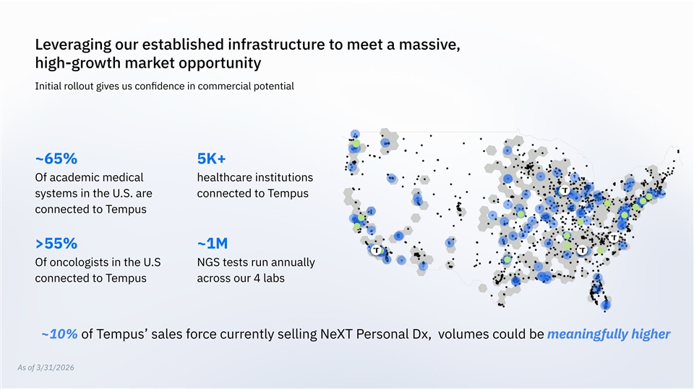
Leveraging our established infrastructure to meet a massive, high-growth market opportunity Initial rollout gives us conﬁdence in commercial potential ~65% 5K+ Of academic medical healthcare institutions systems in the U.S. are connected to Tempus connected to Tempus >55% ~1M Of oncologists in the U.S NGS tests run annually connected to Tempus across our 4 labs ~10% of Tempus’ sales force currently selling NeXT Personal Dx, volumes could be meaningfully higher As of 3/31/2026

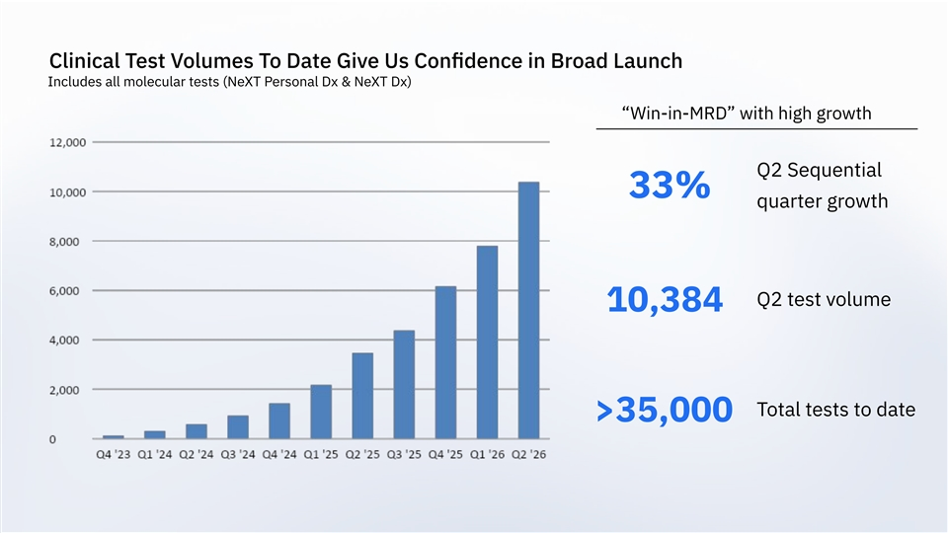
Clinical Test Volumes To Date Give Us Conﬁdence in Broad Launch Includes all molecular tests (NeXT Personal Dx & NeXT Dx) “Win-in-MRD” with high growth Q2 Sequential 33% quarter growth Q2 test volume 10,384 Total tests to date >35,000

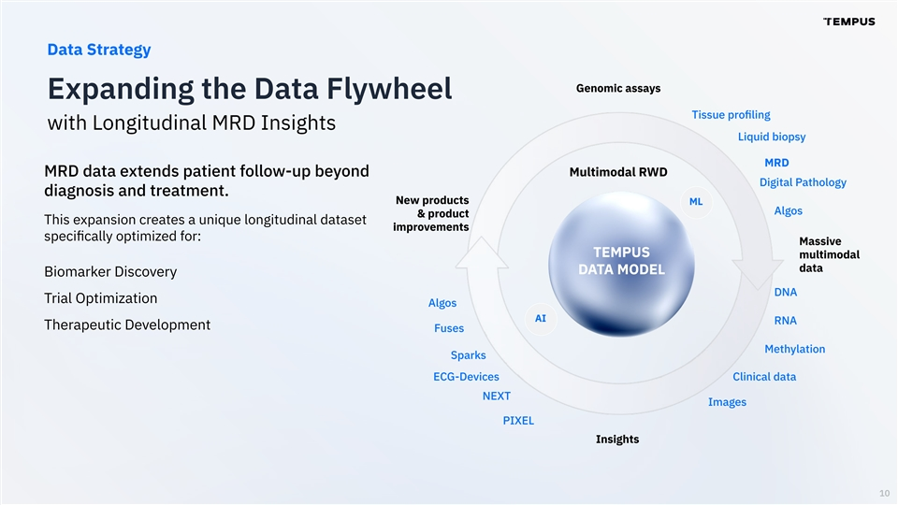
Data Strategy Genomic assays Expanding the Data Flywheel Tissue proﬁling with Longitudinal MRD Insights Liquid biopsy MRD MRD data extends patient follow-up beyond Multimodal RWD Digital Pathology diagnosis and treatment. New products ML Algos & product This expansion creates a unique longitudinal dataset improvements speciﬁcally optimized for: Massive TEMPUS multimodal data DATA MODEL Biomarker Discovery DNA Trial Optimization Algos AI RNA Therapeutic Development Fuses Methylation Sparks ECG-Devices Clinical data NEXT Images PIXEL Insights 10

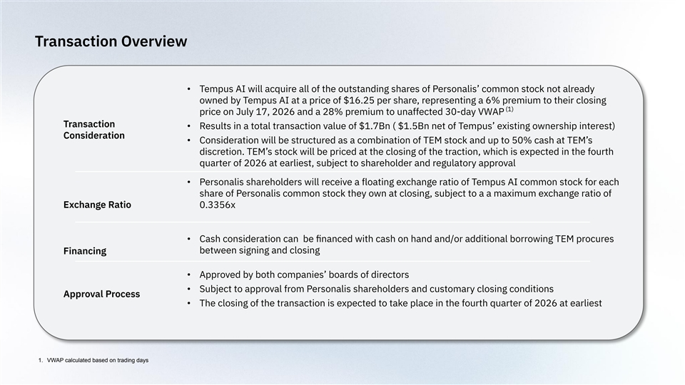
Transaction Overview • Tempus AI will acquire all of the outstanding shares of Personalis’ common stock not already owned by Tempus AI at a price of $16.25 per share, representing a 6% premium to their closing (1) price on July 17, 2026 and a 28% premium to unaffected 30-day VWAP Transaction • Results in a total transaction value of $1.7Bn ( $1.5Bn net of Tempus’ existing ownership interest) Consideration • Consideration will be structured as a combination of TEM stock and up to 50% cash at TEM’s discretion. TEM’s stock will be priced at the closing of the traction, which is expected in the fourth quarter of 2026 at earliest, subject to shareholder and regulatory approval • Personalis shareholders will receive a floating exchange ratio of Tempus AI common stock for each share of Personalis common stock they own at closing, subject to a a maximum exchange ratio of Exchange Ratio 0.3356x • Cash consideration can be ﬁnanced with cash on hand and/or additional borrowing TEM procures between signing and closing Financing • Approved by both companies’ boards of directors • Subject to approval from Personalis shareholders and customary closing conditions Approval Process • The closing of the transaction is expected to take place in the fourth quarter of 2026 at earliest 1. VWAP calculated based on trading days

